Documentation Report

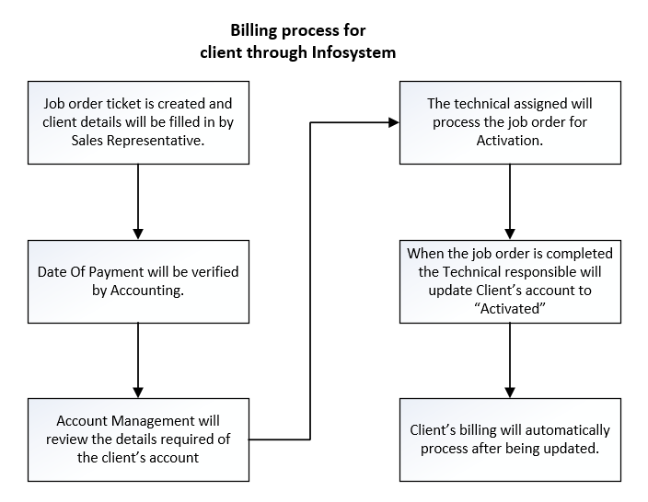Billing Process through Infosystem flowchart:

The flow chart above shows how infosystem creates the client’s account and automatically processes the billing. The system requires the key details of the client to properly function on the aspects of showing the client’s statement of account, status and automated billing.

Breaking down each step of the process to further explain each step for the billing process of a client.

The image below shows step 1 which is generally the creation of the job order ticket in Infosystem. Requiring details of the client as shown in the image below.

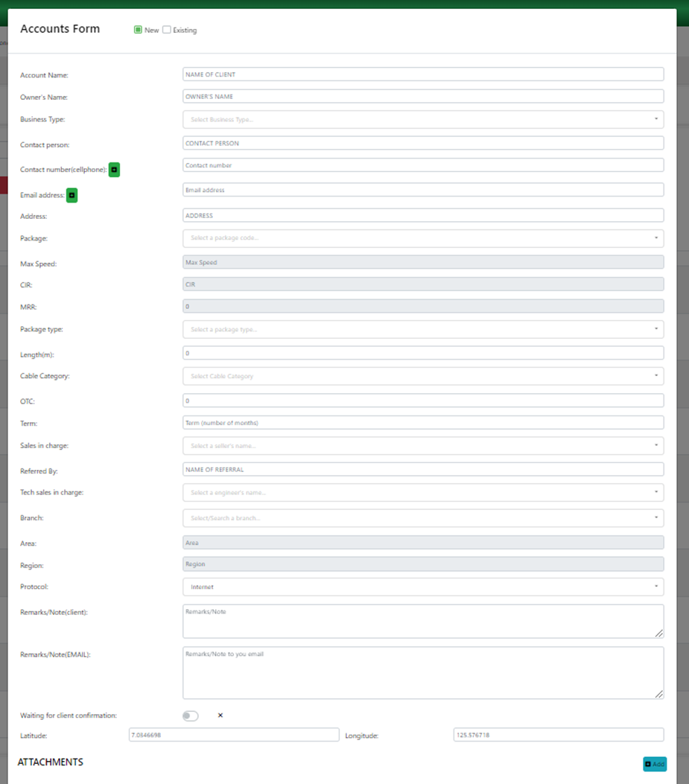

Step 3 of the process which is the verification of date of payment of the client.

After filling in the required details, the account will await for the Date Of Payment update from the Accounting Department.

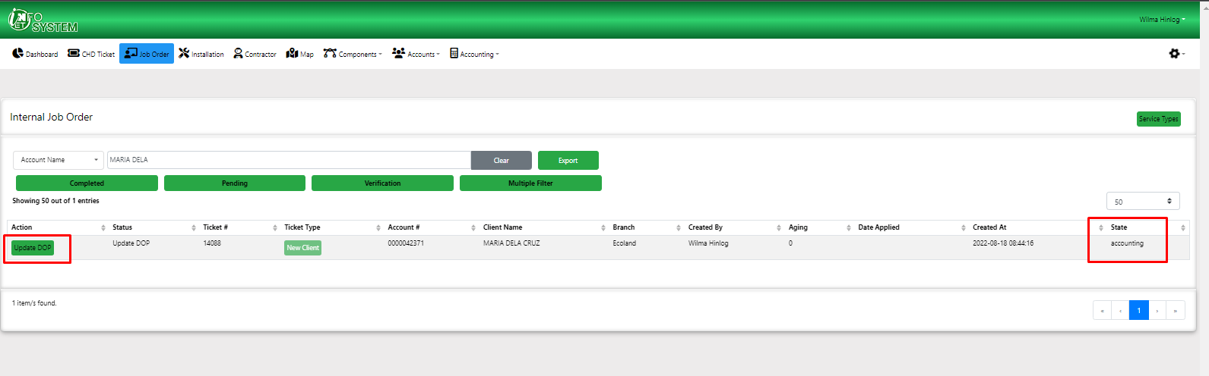

The Date Of Payment function is shown below:

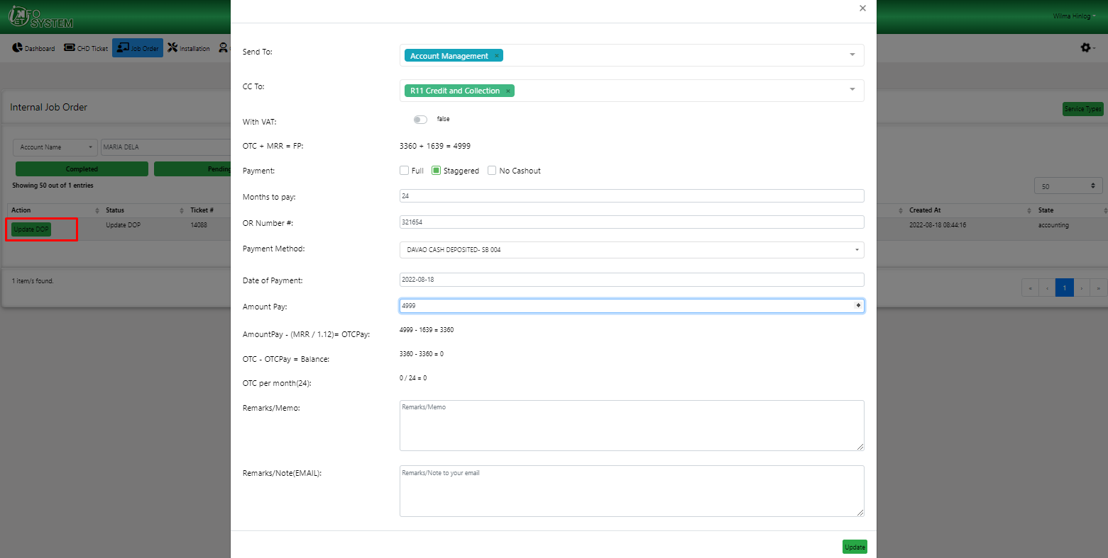

Step 4 of the process, Account Management verifying the details of the client’s contract.

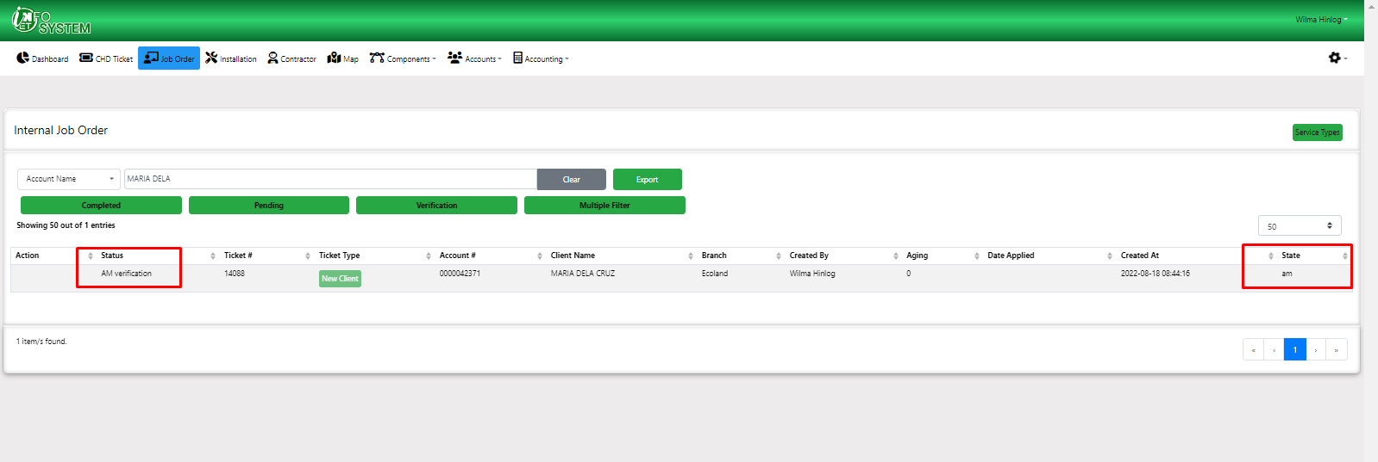

The verification process needs three key details in the Infosystem which are Attachments, Remarks and History logs.

Attachments require details of the client

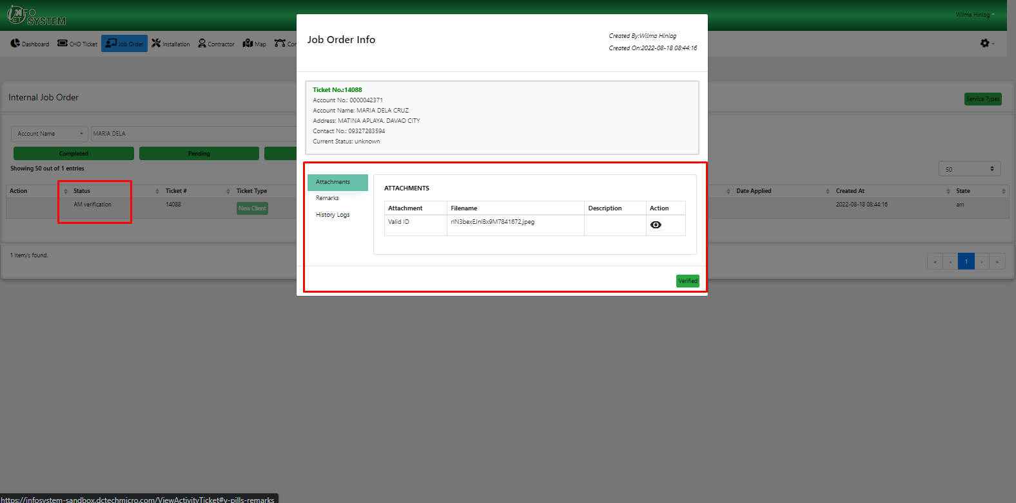

Remarks is information of the client’s status

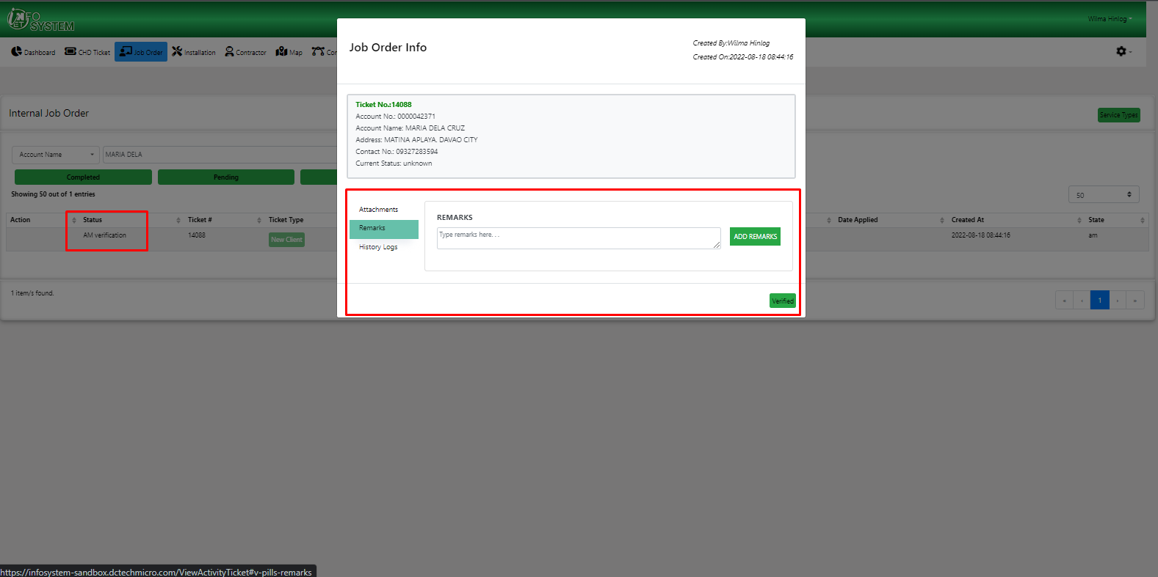

History Logs progress of the Job ticket

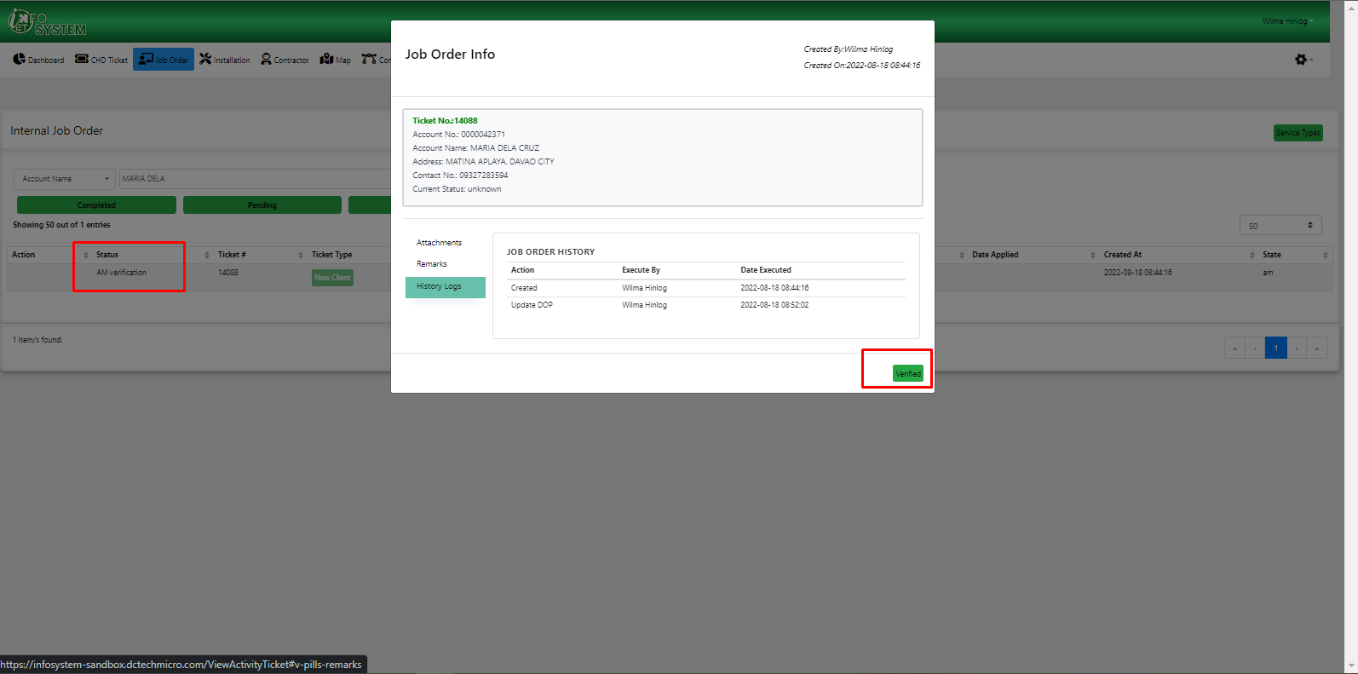

After verification, the Account Management will create the client’s bucket subscription and assign the IP.

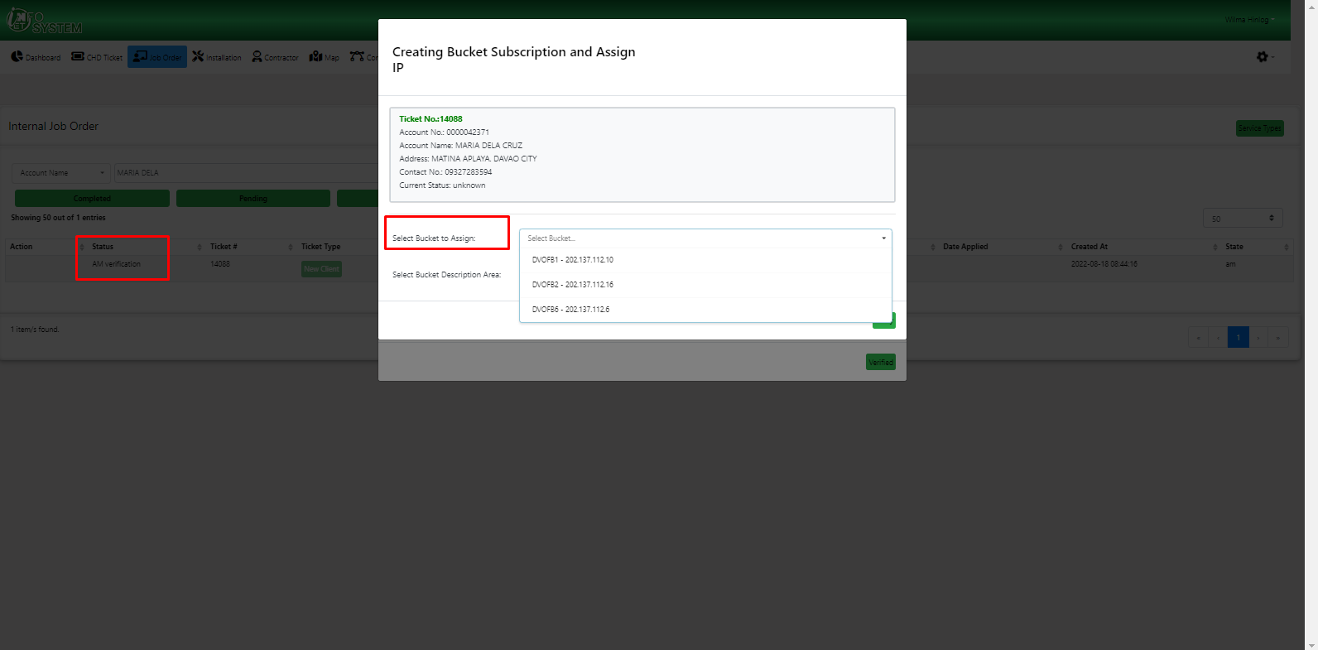

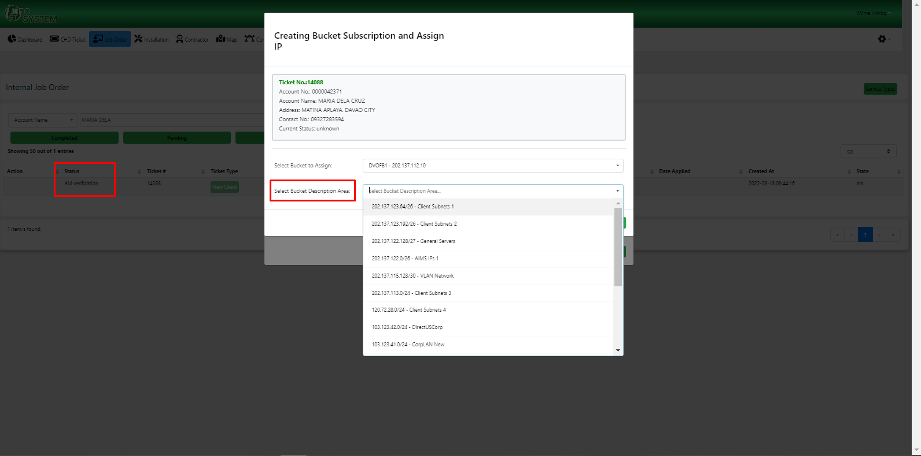

Step 5 is for client’s schedule for activation by the Technical Department

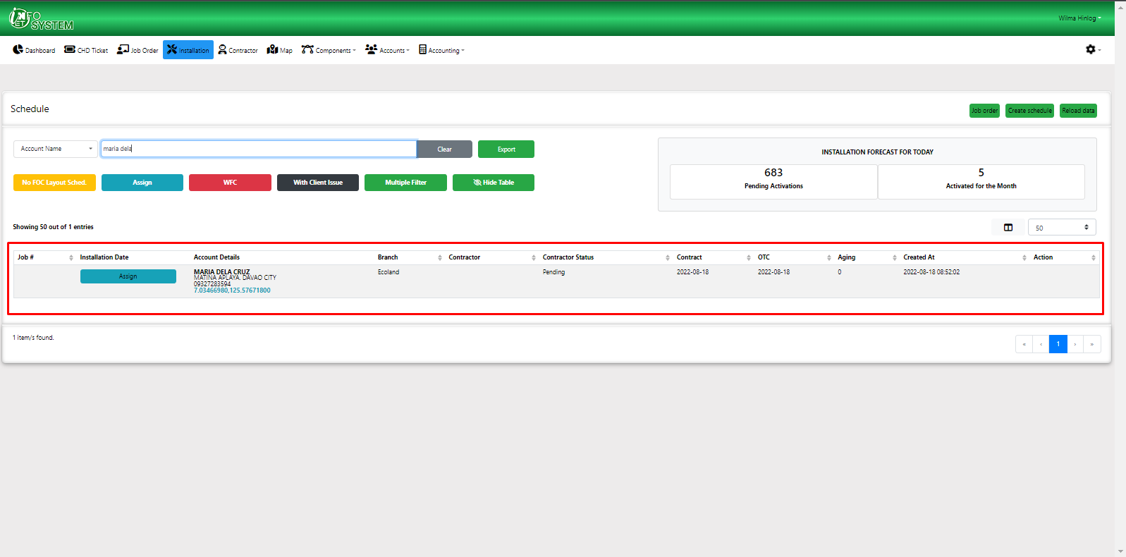

Scheduling function of the Infosystem shows details of the contractor and technical team responsible.

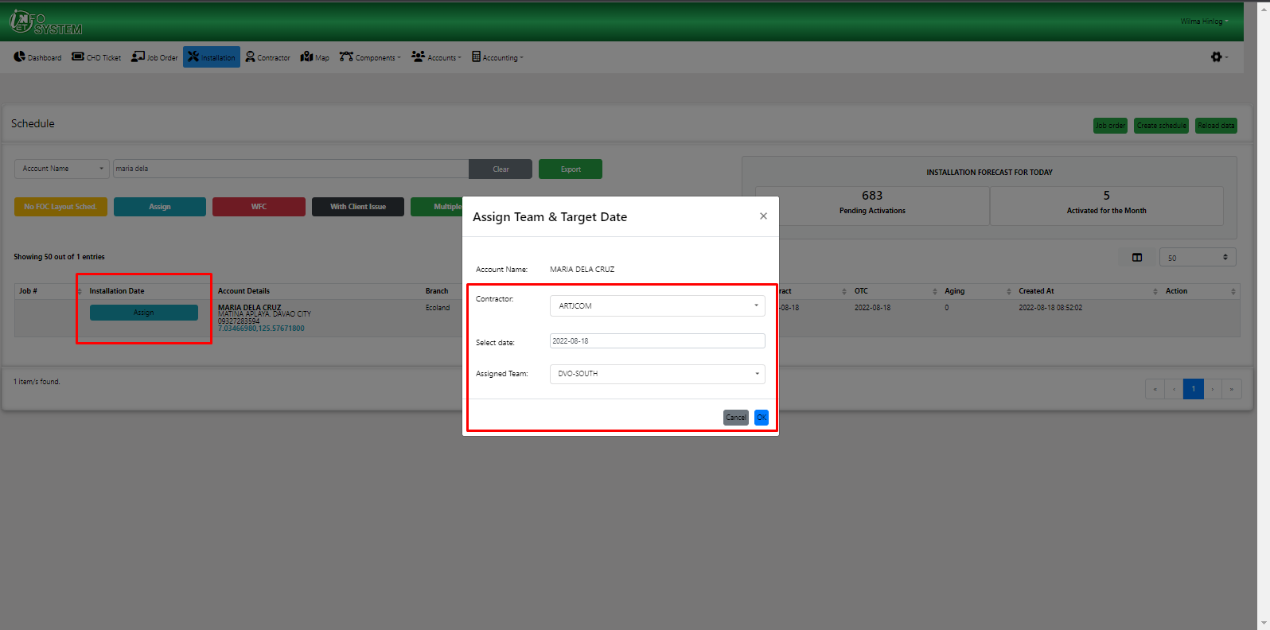

After the inputs of the Technical department for scheduling the client will now be in que for installation.

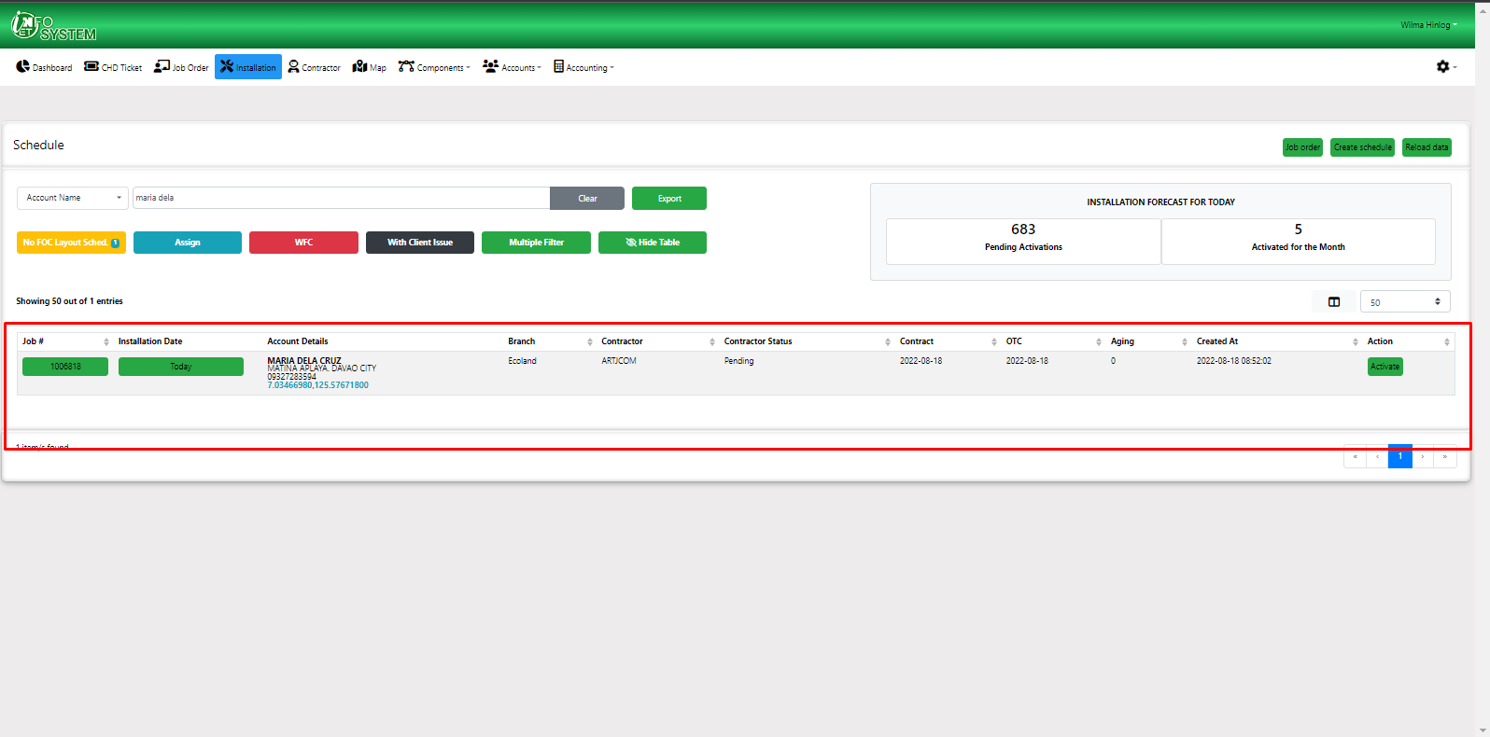

Step 6 After activation of client’s account, the Technical department will update the date of activation in Infosystem.

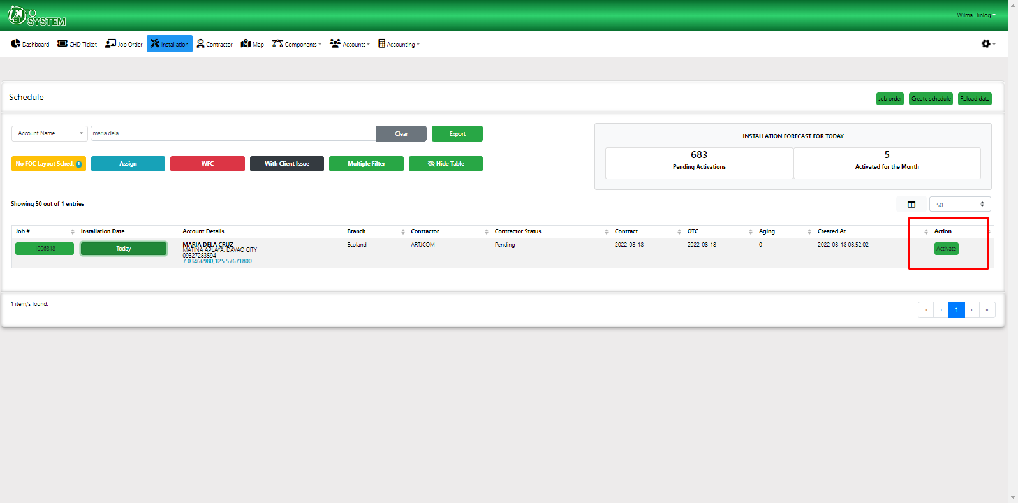

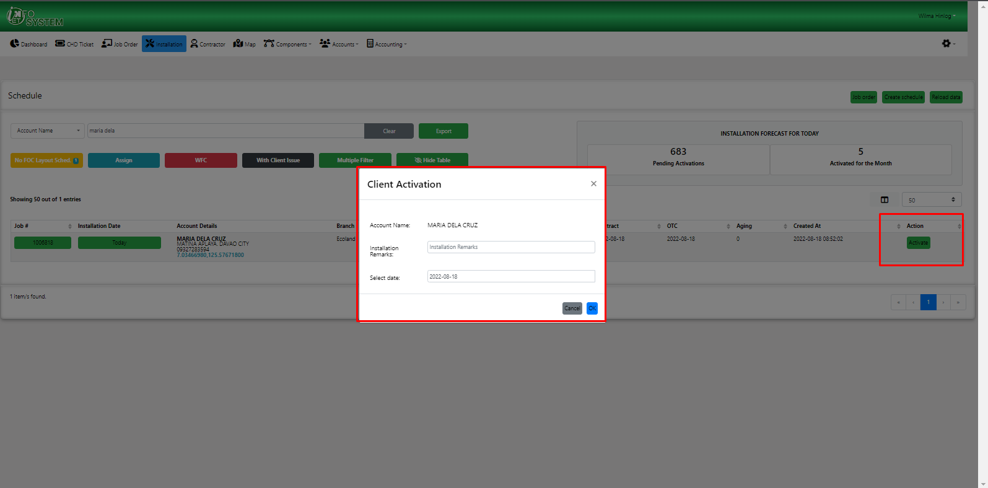

Step 7 Client’s account is fully activated in Infosystem.

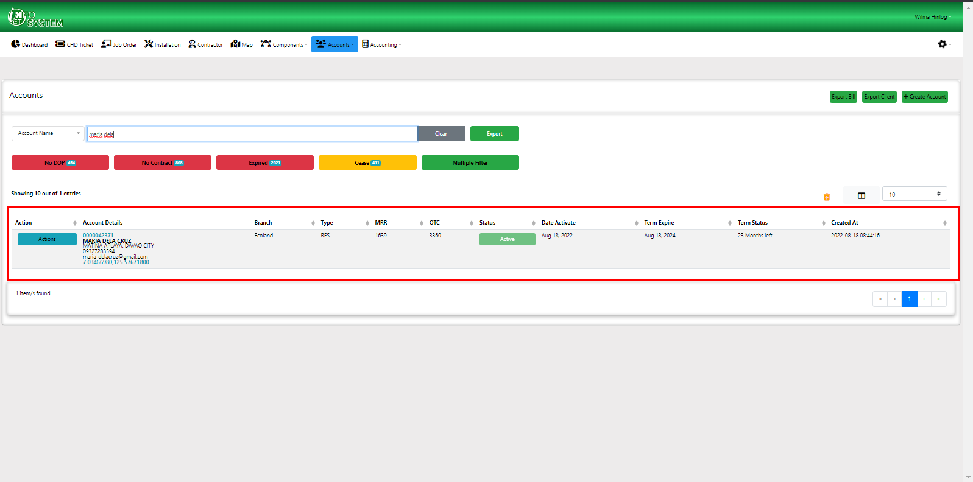

Fully activated accounts will show multiple function for the account status.

- Auto Bill

- CP (change package)

- TD (temporary disconnection)

- OH (on hold account)

- Disconn (Disconnection)

- RP (received payment)

- WHT (with holding tax)

- SOA (statement of account)

- Client MRR Add-ons

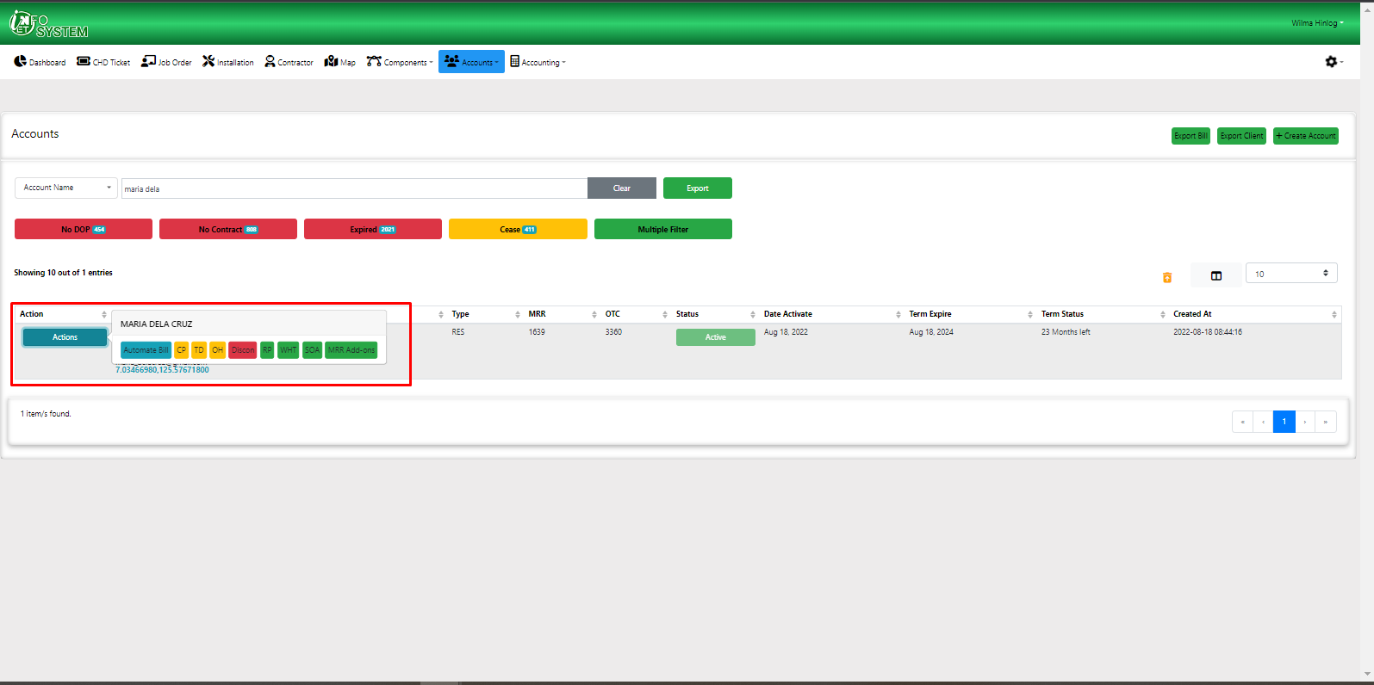

Example of client’s statement of account already plotted for the contract’s term.

